1. Deploy Minikube/Rancher Desktop

This can be performed by calling the following two commands:

choco install kubectl

choco install minikube  
  
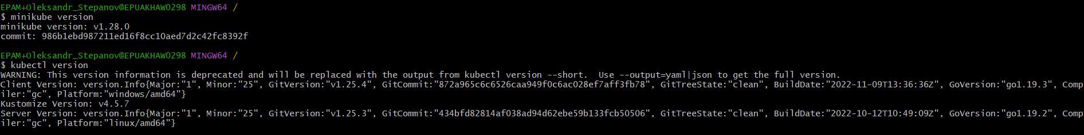

2. Install kubectl and check kubectl is working.

3. Check available nodes.

4. Display detailed information about nodes.

5. Describe kubeconfig.

6. Create basic nginx deployment and deploy nginx in nginx namespace.

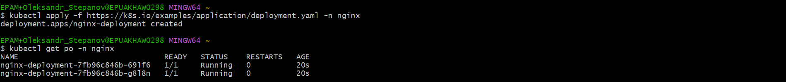

7. Check status of deployment, check pods’ logs. Check information about services. Why services is needed?

Why are services needed?

Kubernetes service mostly serves as a load balancer within the Kubernetes deployment since they’re responsible for routing to the pods when addressing to the IP address that is being listened to.

8. Install Helm 3



9. Deploy Jenkins Helm chart/helmfile from helm public charts repo. Create port-forwarding and reach Jenkins UI via browser.

To start with, let’s launch minikube to deploy our local K8s cluster.

Now that we have minikube deployed, we can add the repo we will pull our jenkins from.

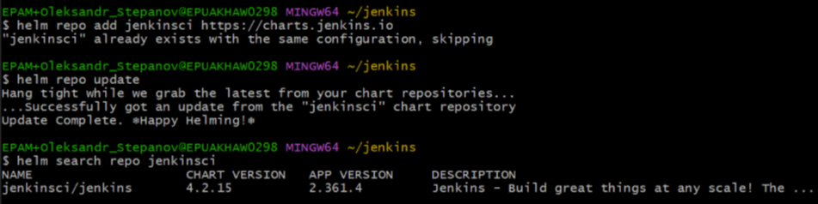

Jenkins requires us to create persistent volume. Let’s create a .yaml file and deploy it.

It’s important here to wait till the status of the volume is set to “Bound”.



Then we should adjust the permissions for the file so that Jenkins could use it.

I lost the output where I use the command, but Jenkins is deployed by performing:  
kubectl create namespace jenkins

chart=jenkinsci/Jenkins

helm install jenkins -n jenkins -f values.yaml $chart

where the file content is copied from the link: <https://raw.githubusercontent.com/jenkinsci/helm-charts/main/charts/jenkins/values.yaml>

Here is how we yield password to enter Jenkins:

The last thing we have to set is port-forwarding:

Testing if it works:

10. Stop minikube.

11. Destroy minikube.

As expected, we can’t use kubectl after deleting minikube.  
